|  |  |  |
| --- | --- | --- |
| ATL Objective The primary goal of risk management is to identify, assess, and manage risks in order to reduce their impact on an organization's goals. Risk management is a proactive process that entails identifying potential risks, analyzing their likelihood and impact, and developing a strategy to manage or mitigate them. Skills | |  | | --- | | Aung Tun LInProfession or Industry | Link to other online properties: Portfolio/Website/Blog |  ExperienceTravel PERK• 2nd Feb to 1st JulyEducationVolunteer Experience or Leadership |

### Project Risk Management

What is Project Risk Management?

The process of locating, evaluating, and reacting to any hazards that can arise over the course of a project is known as project risk management. It is a crucial component of project management that aids in making sure that projects are finished on schedule, within budget, and to the appropriate standard of quality.

Identifying possible risks and their sources, estimating their likelihood and potential effect, creating risk response plans, and monitoring and controlling risks throughout the project are all part of the risk management process.

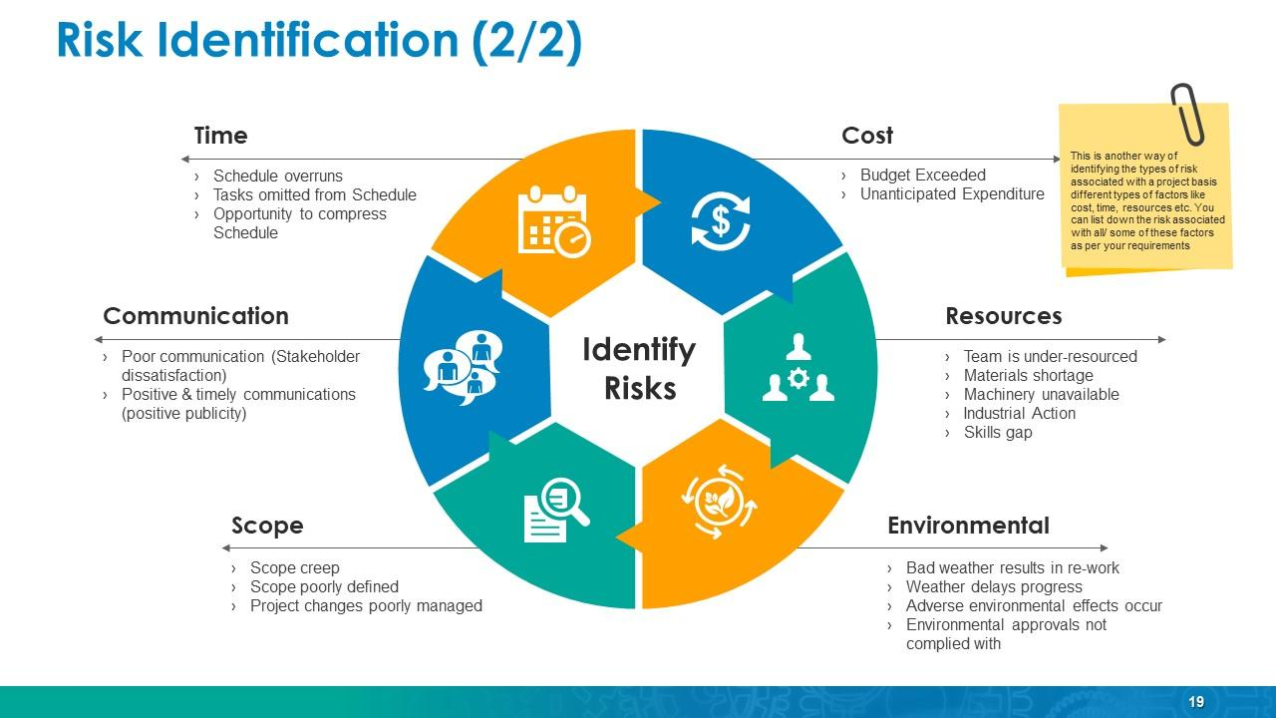

Risk Management Procedure

Risk Identification:

The very first stage in risk management is to identify potential risks to the project. This can be accomplished by brainstorming, reviewing project materials, or conducting a risk assessment.

Risk Prioritizing:

After assessing the risks, they must be prioritized based on their severity and probable impact. This allows project teams to concentrate their attention on the most critical risks.

Risk Response Planning:

Once hazards have been identified, the next stage is to devise a strategy for dealing with them. This may entail avoiding the risk entirely, managing it by reducing its chance or impact, transferring the risk to another party, or accepting the risk.

Risk Analysis:

The assessment process will involve evaluating all identified risks in order to determine the various potential project outcomes. A process of qualification will then be used to distinguish the most critical risks to be addressed and those that can be disregarded.

*Qualitative Analysis:*

The project manager will assess the probability and effect of occurrence for each identified risk using the following technique, with feedback from the project team:

**Probability Chances For the Qualitative Analysis….**

• High - higher over 70%> likelihood of occurrence

• Medium - Between 30%> and 70%> frequency of occurrence

• Low - just under 30%> probability of occurrence

*Quantitative Analysis:*

The effect of risk events that have been prioritized using the qualitative risk method on project activities will be calculated, a numerical rating provided to each risk based on this analysis, and this section of the risk management approach will be documented.



Risks and Its Risk Types

|  |  |
| --- | --- |
| Risks | Its Types |
| Strategic Risk | These are hazards connected with decisions about an organization's aims, strategies, or objectives. Market shifts, competitor movements, regulatory changes, and scientific disruption are all examples of strategic risks. |
| Operational Risk | These are hazards posed by an organization's internal processes, technology, and personnel. System failures, human mistakes, supply chain disturbance, and fraud are all examples of operational hazards. |
| Financial Risk | These are threats posed by financial market circumstances or economic developments. Credit risk, market risk, interest rate risk, and financial leverage are all types of financial hazards. |
| Legal Risk | These are the risks posed by laws, regulations, or legal acts. Noncompliance with rules or regulations, litigation, and government investigations are all examples of legal risks. |
| Reputational Risk | These are the risks associated with a company's reputation or brand being harmed. Bad attention, product defects, and moral violations are all examples of reputational risks. |
| Security Risk | These are the risks posed by malicious or unintended attacks on an organization's assets, systems, or people. Cyberattacks, terrorism, theft, and sabotage were examples of security risks. |

Risks Impact and Its Potential Risks

|  |  |  |  |  |
| --- | --- | --- | --- | --- |
| Rating/Probability | 1=high | 2=medium-high | 3=medium-low | 4=low |
| A=100 | Very high exposure | Very high exposure | High exposure | Moderate exposure |
| B=50 | High exposure | Moderate exposure | Moderate exposure | Low exposure |
| C=20 | Low exposure | Low exposure | Low exposure | Low exposure |

Risk Impact:

The effect or consequence of a risk event on a project, organization, individual, or society is referred to as risk impact. The potential hazards posed by a risk event are determined by the severity of the impact as well as the chance of the event occurring.

Low Impact Risk: These risks have a minimal effect on the project, organization, or individual and thus are improbable to have a significant impact on the result. Minor equipment failures, the temporary absence of a team member, or a delay in a non-critical task are examples of low impact risks.

Medium Impact Risk: These risks have little influence on the project, organization, or individual, but they may cause temporary interruptions or cost increases. Medium impact risks include significant equipment failures, lengthy team member unavailability, or delays in a crucial activity.

High Impact Risk: These risks have a large influence on the project, organization, or individual, and can have a big impact on the outcome or cause severe harm. Catastrophic equipment failures, the death of key team members, or a severe delay in an essential activity are examples of high impact risks.

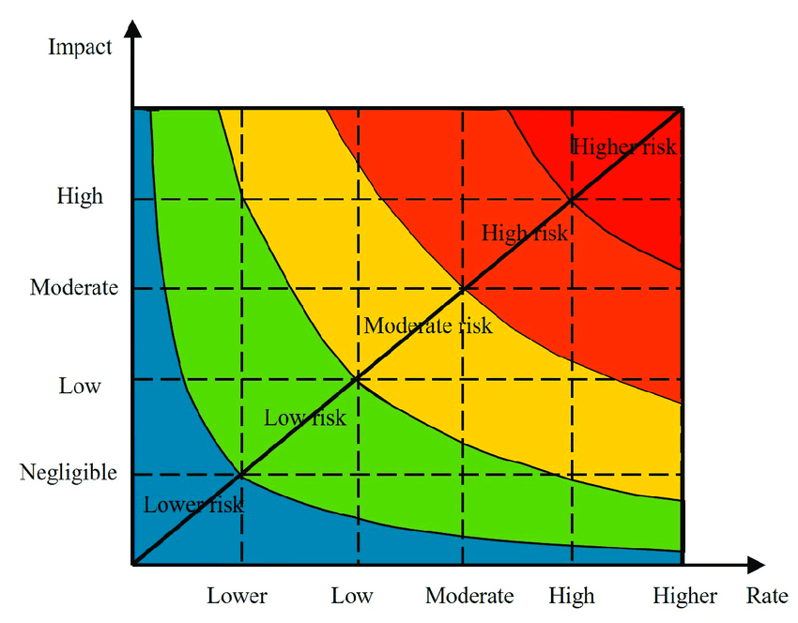

Potential Risks:

A risk that hasn't yet occurred but has the capacity to occur in the future is referred to as a prospective risk. Potential hazards must be identified and managed since they can develop into actual dangers if not handled. A new rival joining the market, a change in legislation that might influence an organization, or a natural catastrophe that could affect an area where a project is being carried out are all examples of possible hazards.

* Potential hazards are risk occurrences that have not yet occurred but may do so in the future.
* Identifying possible hazards is an important component of risk management because it helps companies to plan for and limit the effect of potential risk occurrences.
* The possibility of occurrence and possible effect of such dangers should be considered.
* To address possible hazards and reduce their chance and effect, risk management measures should be used.
* Effective risk management entails monitoring and analyzing possible hazards on a regular basis, as well as adopting risk mitigation methods as needed. (Kylie, 2022)

### Mitigation and Avoidance of Risk

To ensure the success of a vehicle inventory management system, potential risks must be minimized and managed. Here are some suggestions for mitigating and controlling potential risks:

**Implement a solid inventory management system:** A solid inventory management system is essential for reducing inventory management risks. Inventory levels, orders, sales, and returns should all be monitored by the system. It should also have safeguards in place to defend against loss or theft.

**Audit your inventory on a regular basis:** Auditing your inventory on a frequently can assist you identify any differences in your inventory records. Audits can aid in the detection and resolution of problems such as missing or stolen inventory, incorrect inventory counts, and faulty records.

**Invest in good security measures:** When managing automobile inventory, safety is essential. You should have a system in place to protect your inventory against theft, fire, and other possible threats. You can, for example, install surveillance cameras, burglar alarms, and other security devices.

**Train your employees:** Your employees should be properly trained in inventory management best practices. They should be able to use the inventory management system, keep accurate records, and handle inventory safely.

**Have a backup plan:** A backup plan can help you prepare for unexpected events such as natural disasters or power outages. Procedures for securing inventory, relocating inventory, and resuming operations should be included in your contingency plan.

**Maintain good supplier relationships:** Keeping good supplier base can help you mitigate potential inventory risks. Your suppliers can help you identify potential inventory issues and providing timely solutions.

You can reduce and manage potential risks associated with automobile inventory management by following these tips.

### Overcoming its Risk

A project manager must be able to identify potential hazards that could jeopardize the project's success. Budget overruns, missed deadlines, scope creep, resource constraints, stakeholder conflicts, and technological challenges are all common hazards. These risks could be the result of inadequate making plans, a lack of expertise, a breakdown in communication, or unexpected external circumstances. To successfully complete a project risk must be identified and managed. It necessitates a proactive approach that includes continuous monitoring, emergency preparedness, and risk-reduction techniques. By being prepared and addressing risks early on, the project team can avoid unfavorable outcomes and ensure a project's success. (Maxx, 2022)

**References:**

# References

Kylie, 2022. *Process of Risk Management.* s.l., https://www.researchgate.net/publication/331783796_Process_of_Risk_Management.

Maxx, 2022. Introduction to Risk Management.